*Florida International University*

*School of Computing and Information Sciences*

CIS 4911 - Senior Capstone Project

Software Engineering Focus

Feature Document

User Story #626

**Team Member:**

Andrew Mitchell

**Product Owner(s)**:

Francisco R. Ortega

**Mentor(s)**:

Francisco R. Ortega

...

**Instructor**: Masoud Sadjadi

**User Story - Enable Alpha Coloring for Shapes**

* As a User I would like the Option to use Alpha coloring to change the transparency of the colors I use.

Acceptance Criteria

* Restructure the code to enable our ‘shapes’ to use alpha coloring instead of only RGB.
* Be able to change the alpha color value for our next draws
* Add additional ‘mode’ buttons for transparency (aka alpha coloring).

**Use Case – Change Alpha Color**

Use Case

Be able to change transparency of color drawing.

Details:

Actor: User

Pre-conditions:

Colors must be working. Must be able to use multitouch buttons.

Description:

Use case begins when the user changes Alpha coloring (called transparency). This should reflect in the mode box as well as wherever the user draws.

Post-conditions:

All drawings after changing alpha should be more or less transparent based on which button they pressed.

Decision Support:

Frequency: Often. Transparency can add a lot of depth to drawings and make them much more diverse.

Criticality: Medium. It is a very important feature for the future. A paint program lacking transparency is lacking in itself.

Risk: Low. We have to enable alpha coloring only. Very simple, just a bit of testing.

Reliability: Highly.

Mean time to Failure –  Almost never. It should only ‘fail’ when you cannot make an object more or less transparent than it already is.

Availability – Available with a keyboard or when the ‘mode buttons’ are open.

Performance:

N/a

Supportability:

Must work with ACER Multitouch.

Leap motion device

Modification History:

Owner: Andrew Mitchell

Initiation date: 02/28/2016

Date last modified: 02/28/201

**Use Case Diagram**

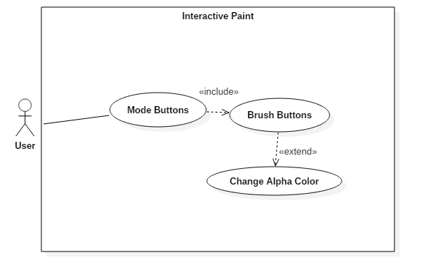

**Sequence Diagram**

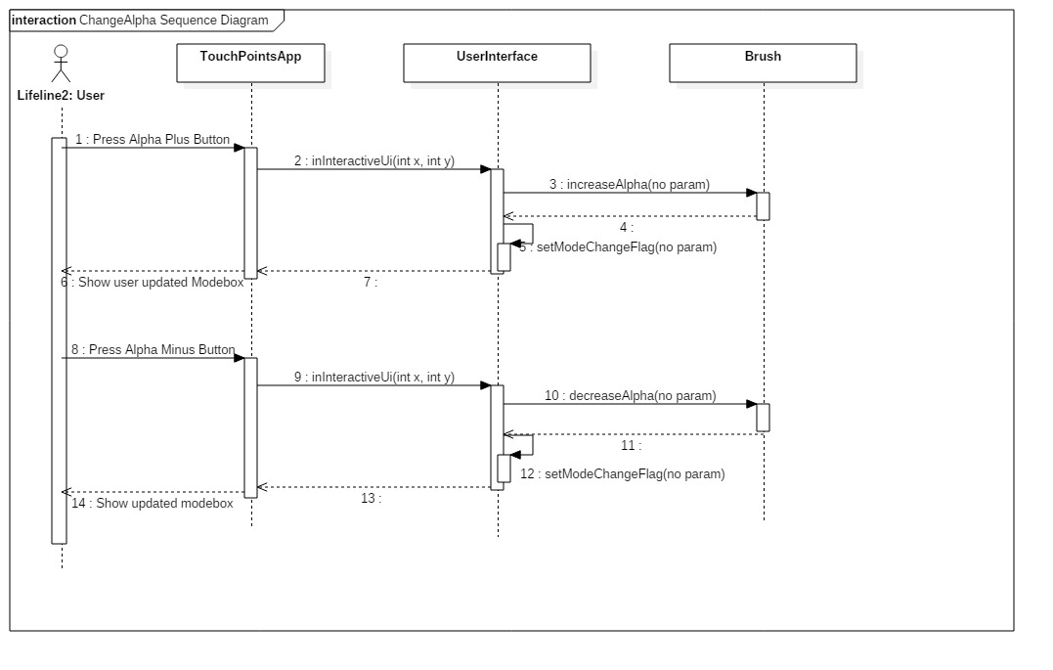

**Class Diagram**

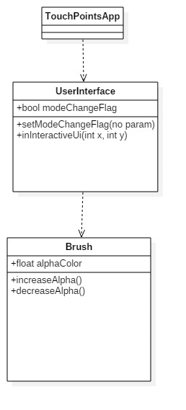

**Unit Test**

Sunny Day :

User increases Alpha

Successfully made color less ‘transparent’ based on current color

User decreases Alpha

Successfully made color more transparent based on background color and current color

Rainy Day Tests :

* Decrease Alpha, then change shape and color
  + Alpha successfully changed even after changing shape and color
* Increase Alpha, then change shape and color
  + Alpha successfully changed even after swapping shape and color

**Integration Test**

Currently works with all shapes and all colors

The drawings are working with each individual layer as well.

The leap motion has alpha capabilities

The Real Sense has alpha capabilities

The Multitouch has alpha capabilities.

**User Guide**

Press the brush button located in the top left set of buttons.

Then you can change the alpha value making it larger or smaller.

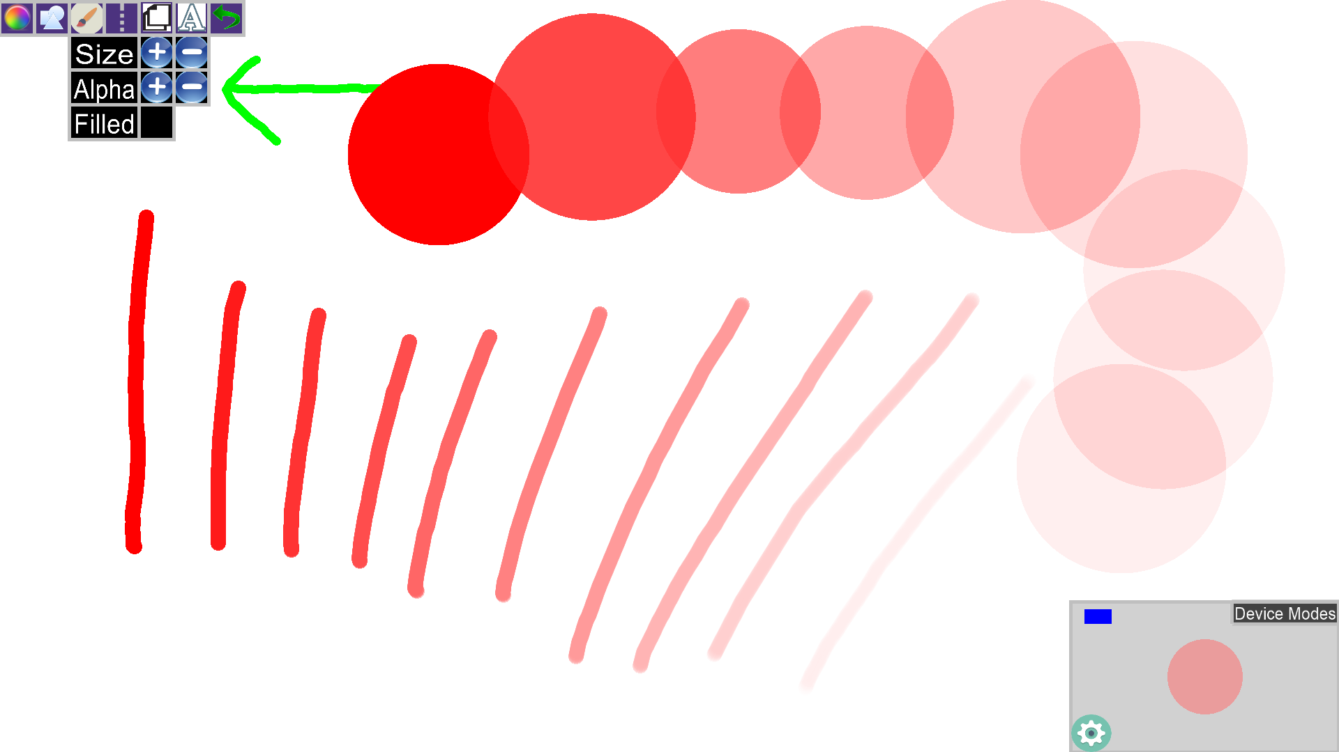

This image shows the alpha in action. You can see that the color slowly fades away. Decreasing alpha will effectively increase transparency, while increasing alpha decreases how transparent a shape is.

**Glossary**

Alpha Coloring : The fourth color in libcinder’s coloring. Red, Green, Blue, **Alpha**. It tells their draw function how ‘transparent’ the color should 1. 1.0 being fully visible, 0.0 being completely transparent.

Transparency : Another term used interchangeably for alpha coloring (Simple term for user to understand).